

USING CANVA AS A TOOL

Canva is a great tool to assist teachers and faculty alike towards creating on brand graphics for your school. We have created examples to use across social media and through your email messaging.

You can recreate these easily through Canva and even create a teacher account here.

In each template, we added a note section. Click the icon shown below for instructions on how to make each template your own.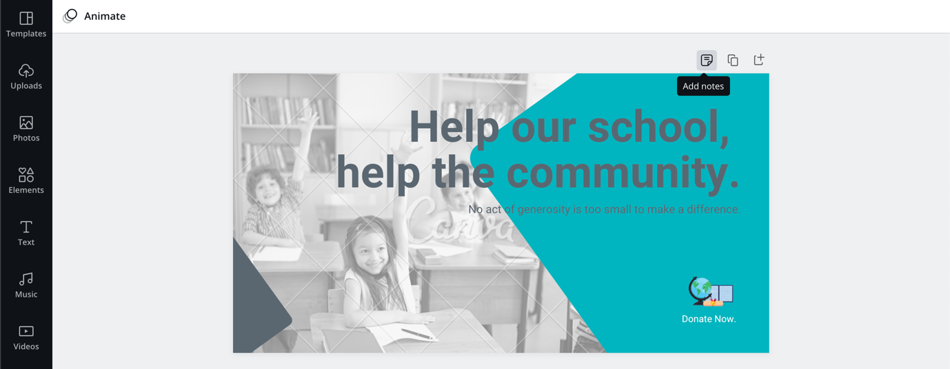

Top tip: To make sure your colors are following your brand guidelines, upload an image of your logo/crest to the design and Canva will pick out all the colors from your uploaded image (see example below). Once you have changed the colors, feel free to remove the uploaded image, resize or move around! 